

JOB DESCRIPTION

Job Title | PA to Director

Salary | £23,541 – 28,672 plus local weighting of £626 per annum

Directorate: | Delivery | Section/Location:
Grade/Salary Range | BG-H | Work style: | Flex

Key Objectives of the role
To provide high quality, confidential support for the Director, in all aspects of work, exercising the discretion expected of a Director’s Support Assistant

Designation of post and position within departmental structure

Daily and monthly responsibilities
- To provide proactive support to the Director, including secretarial and high-level administrative duties, screening telephone calls, answering ad hoc queries and requests – routine and non-routine
- Efficient diary management to include, making arrangements for meetings, workshops and other events as required (including travel/accommodation arrangements)
- Collate the timely preparation and circulation of agendas, minutes and papers, taking minutes of meetings and following up action points
- Assisting with the preparation of reports and presentations including background research as required ensuring reports meet Corporate timescales
- Producing confidential documents, briefing papers, reports etc
- Carrying out specific projects and research as required
- Making decisions as appropriate and delegating work to others in the Director’s absence
- Provide support to other members of the Corporate Management Team as required and particularly in the absence of their support assistant

Such other duties as may from time to time be necessary, compatible with the nature of the post. It should be noted that the above list of main duties and responsibilities is not necessarily a complete statement of the final duties of the post. It is intended to give an overall view of the position and should be taken as guidance only

Scope of role
No budgetary responsibility

Will need to liaise will Members, Executive Members and Senior management on a daily basis and be comfortable challenging where necessary

Commitment to the Council’s Equal Opportunities policy at all times

Commitment to working within the bounds of the Data Protection Act and GDPR legislation at all times

PERSON SPECIFICATION
KEY CRITERIA | ESSENTIAL | DESIRABLE
Skills and qualifications | Minimum A level education or equivalent  PA/Secretarial and administrative qualifications | ECDL
Competence Summary  (Knowledge, abilities, skills, experience) | Proficient in MS Office i.e. able to use the majority of the systems functions without assistance and communications technology to access and communicate information.  Experience supporting on a 1:1 basis at Board level including extensive, well planned, diary management.  Confident negotiating skills  Ability to think ahead and forward plan effectively.  Ability to create letters, emails, presentations, and documents competently.  Problem solving skills and accurate numeracy – works accurately with figures.  Attention to detail and accuracy.  Accurate keyboard skills, rapid data input.  Good organisational skills.
Work-related Personal Requirements | Regularly demonstrates a positive attitude  Discrete and used to dealing with confidential material.  Excellent attention to detail.  Highly credible at both a personal and professional level and capable of acting with political sensitivity.  Able to work without supervision using own initiative.  Communicates effectively with people at different levels using all access channels providing appropriate information and advice to the public/and or customers.  Work effectively under pressure in a busy, diverse and demanding environment.  Tactful and diplomatic, open-minded, and adaptable, focussed, resilient, and persistent as appropriate.  Prepared to be reasonably flexible in work hours to meet the requirements of the job.
Other Work Requirements

KEY CRITERIA | ESSENTIAL | DESIRABLE
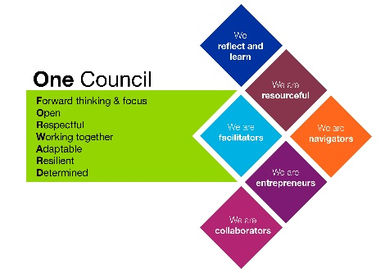
Role models and
demonstrates the
Council’s values and
behaviours

All staff should hold a duty and commitment to observing the Council’s Equality & Diversity policy and procedures at all times. Duties must be carried out in accordance with relevant Equality & Diversity legislation and Council policies/procedures.

