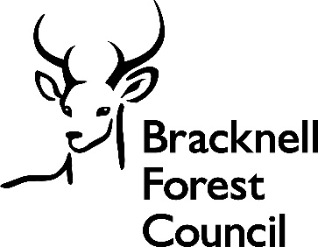

JOB DESCRIPTION

Job Title | Covid Response Project Manager

Salary | TBC

Directorate: | Chief Executive’s Office | Section/Location: | Covid Response
Grade/Salary Range | Indicative – grade E | Work style: | Home-flex

Key Objectives of the role
No more than three points should be included here as it is an overview for the purpose of the role
- To manage the effective and efficient delivery of Covid response projects supporting CMT’s objectives throughout each service review lifecycle to a successful conclusion

- To manage the delivery of Covid Response projects and related activities, identifying interdependencies and managing risks to enable each project to deliver the target health protection outcomes and deliverables as set out in each project specification and scope, working with external partners, programme and project cells and team members.

- Project managers may support more than one Covid response project, be asked to change projects or take on new areas of work as the needs of the Covid Response programme evolve in response to changes in government guidance and legislation and as we move towards recovery

Designation of post and position within departmental structure
Evidence via an organisation chart, whom the post reports to, include direct reports into the role if applicable
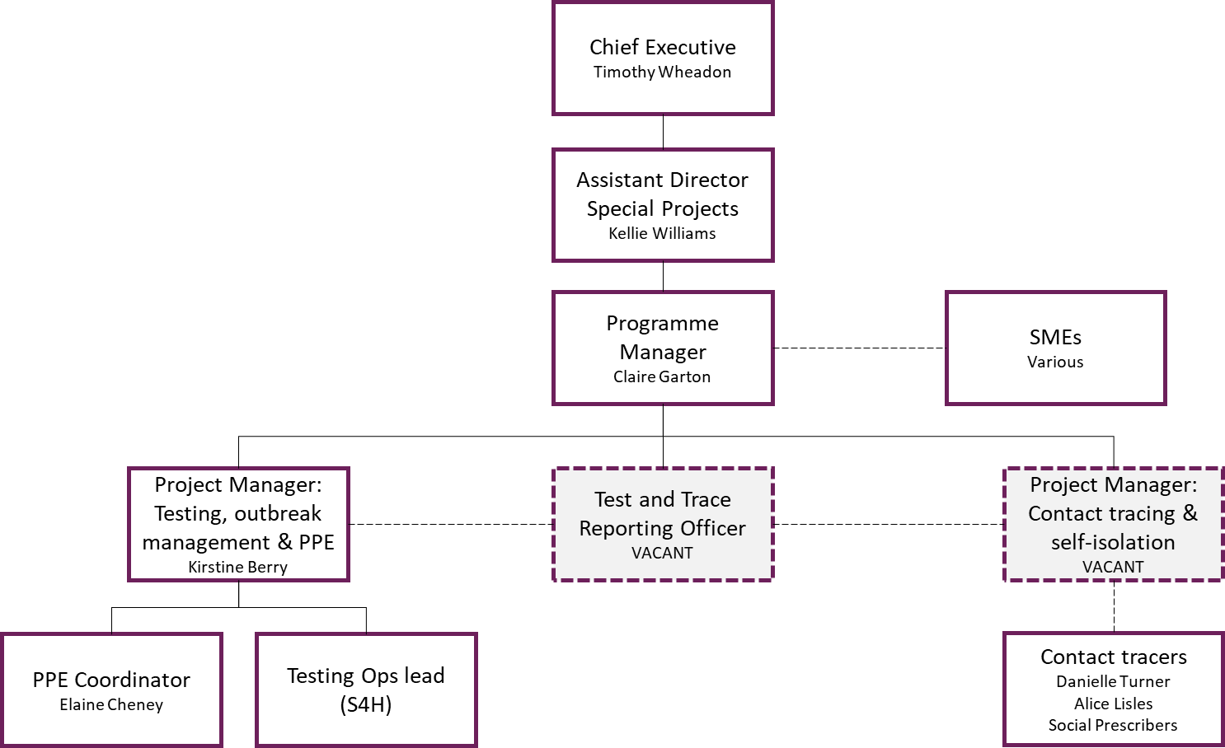

The post holder will be part of the council wide Covid Response Team based in the Chief Executive’s Office, reporting to the Covid Response Programme Manager and working closely with the Assistant Director: Special Projects and Assistant Director: Public Health. The post holder will supervise the work of a team of contact tracers, although formal line management will sit within Public Health.

Daily and monthly responsibilities
List in order of importance. Group Similar tasks together. Maximum of 12 entries
- Effectively manage and lead the delivery of the projects within the council’s Covid Response programme, including governance arrangements, the coordination of plans, resources, budgets, risks, quality, performance and delivery. Ensure the provision of regular and accurate progress reports for key stakeholders, including CMT.
- Ensure that the Covid Response programme continues to fulfil its obligations in line with guidance provided by the Department for Health and Social Care, Public Health England and local leadership decisions. This will include designing, planning and managing key projects related to the council’s Covid response, including:
- Outbreak control
- Testing
- Local contact tracing
- Self-isolation
- PPE
- Vaccinations
- Build effective relationships with the project sponsors, project team and any external partners responsible for delivering the project to effectively engage, persuade and influence on the target outcomes
- Support the identification of any gaps in knowledge and experience, as well as resource pressures within the project team, necessary for a successful outcome and evaluation options for addressing any shortfalls in developing a robust resource plan.
- Ensure project deadlines are met in a timely and efficient manner and support the delivery of regular engagement and communications activities to involve stakeholders
- Ensure change is managed effectively and consistently within each project, working collaboratively with Public Health Behavioural Insights officer and Communications and marking officers to embed this change.
- Manage and record costs of the delivery of the project, including managing the process to request additional funding to support the project deliverables as necessary, including preparation of all scoping paperwork for CMT. Complete monthly funding returns to central government.
- Ensure benefits are assessed at the start of the project and recorded throughout until project closure, with lessons captured for the benefit of future projects within the overall programme.
- Managing timely engagement, communication and information dissemination for the project and ensuring each project develops and implements a comprehensive engagement plan. Engaging with and managing external partners supporting specific projects.
- To reflect and learn from experience taking a proactive approach to personal development and learning about change management, modelling the council’s behaviours to others.

Scope of role
Consider budget/resource control, impact on community
Required to manage and motivate multi-disciplinary project teams.

The council’s Covid Response programme has a deep and substantial impact on all areas of the council and the way in which residents and staff can continue to safely access services during the pandemic.

There is contact with elected members, Chief Executive, Executive Directors, Senior managers, central government departments, Public Health England, partners and the voluntary sector to influence and to work with them to find mutually acceptable solutions to problems, issues and the management of risk.

Commitment to the Council’s Equal Opportunities policy at all times

Commitment to working within the bounds of the Data Protection Act and GDPR legislation at all times

Such other duties as may from time to time be necessary, compatible with the nature of the post. It should be noted that the above list of main duties and responsibilities is not necessarily a complete statement of the final duties of the post. It is intended to give an overall view of the position and should be taken as guidance only.
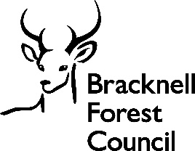

PERSON SPECIFICATION
KEY CRITERIA | ESSENTIAL | DESIRABLE
Skills and qualifications | Educated to degree level or equivalent relevant experience | Prince 2 or equivalent Project Management qualification
Competence Summary  (Knowledge, abilities, skills, experience) | Understanding of and commitment to the requirements of safeguarding children, young people, vulnerable adults and promoting their welfare.  Proven record of ability in managing and delivering strategic projects, ideally within a political environment.  Ability to identify challenges and critical success factors for the success of each project.  Proactive approach to management of risks and issues resolution.  Strong people management skills.  Provides leadership and direction to project teams and key stakeholders.  Ability to build productive relationships, persuade and influence senior officers and stakeholders.  Ability to think critically and challenge project deliverables and progress.  Able to take a creative approach to problem solving.  Proven ability to present complex information in an easily understandable way, both verbally and in writing.  Uses negotiation skills and change control processes to agree changes to scope, deliverables, resource costs and timescales on projects.  Track record of leading work in a complex, multi stakeholder environment.  Experience of managing projects across organisational boundaries and with multiple stakeholders.  Experience of engagement and communications planning and activity delivery; including organising meetings and workshops.  Proven ability in demonstrating a wide range and high level of consultancy skills, with particular emphasis on collaborative working. | Knowledge of national policy relating to Local Government services and funding.  Good knowledge of business solutions in the public sector.  Good knowledge of Covid regulations and processes.  Proven business case preparation.
Work-related Personal Requirements | The post holder must hold a full UK driving licence (or valid equivalent). Non-UK licences must be converted to UK licences in the first six months of employment.  Ability to work flexibly balancing a number of competing tasks and projects simultaneously, often under pressure.  Excellent organisational skills.
Other Work Requirements | The ability to converse  easily with members of the public and respond effectively to questions in spoken English  Ability to attend occasional evening and/or weekend engagement and consultation meetings, if required.

KEY CRITERIA | ESSENTIAL | DESIRABLE
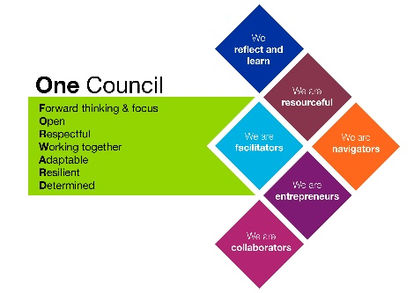
Role models and
demonstrates the
Council’s values and
behaviours

All staff should hold a duty and commitment to observing the Council’s Equality & Diversity policy and procedures at all times. Duties must be carried out in accordance with relevant Equality & Diversity legislation and Council policies/procedures.

