

JOB DESCRIPTION

Job Title | Social Worker/Hospital Social Worker

Salary | £29,577 - £33,782

Directorate: | People | Section/Location: | Adult Community Team  Time Square
Grade/Salary Range | BG G | Work style: | Free

Key Objectives of the role
- To apply a strength-based approach, using the conversations model to connect people to their community/social network, and problem solve together
- Work with people, including advocates and carers, to develop person-centred plans designed to meet needs in ways that maximises independence, choice and control, and are legal and affordable
- Ensure that, all policies and procedures of the department are adhered to.

Designation of post and position within departmental structure
Executive Director
People’s Directorate
Other DMT Members
Assistant Director: Adult Social Care
Head of Service
Other Heads of Service
Community Services Manager
Senior Social Workers and Senior Occupational Therapists
Assistant Community Services Managers
Social Workers/ Support
Co-ordinators Complex

Daily and monthly responsibilities
- To participate in the duty arrangements for the team.
- To apply a strength-based approach, using the conversations model to connect people to their community/social network, and problem solve together.
- Make referrals for specialist assessments/intervention as appropriate.
- Work with people, including advocates and carers, to develop person-centred plans designed to meet needs in ways that maximises independence, choice and control, and are legal and affordable.
- Work with family carers to identify their needs as carers and to develop appropriate plans with the carers to meet those needs.
- When necessary, complete the Resource Allocation System and present support plans for approval in accordance with Scheme of Delegations.
- Provide support for the appropriate arrangement and implementation of those plans.
- Ensure that, throughout this work, all policies and procedures of the department are adhered to.
- Participate in safeguarding assessments and planning.
- Participate in MDT’s and discharge planning meetings.
- To act in the best interest of an individual who lacks mental capacity, using the principles defined in the Mental Capacity Act (2005) to maintain their safety until a time that capacity returns or alternative arrangements are made.

Scope of role
The people supported by the department are vulnerable. Failure to carry out this role appropriately will place people at risk of harm, and the Council at reputational risk, and risk of litigation.

This position has access to information on matters of a confidential nature relating to work of NHS services, social services and/or the health and personal affairs of people who use our services and staff. Under no circumstances should such information be divulged or passed on to any unauthorised person(s) or organisations.

Commitment to the Council’s Equal Opportunities policy at all times

Commitment to working within the bounds of the Data Protection Act and GDPR legislation at all times

Such other duties as may from time to time be necessary, compatible with the nature of the post. It should be noted that the above list of main duties and responsibilities is not necessarily a complete statement of the final duties of the post. It is intended to give an overall view of the position and should be taken as guidance only.


PERSON SPECIFICATION
KEY CRITERIA | ESSENTIAL | DESIRABLE
Skills and qualifications | - Recognised Social Work qualification and registered with Social Work England  - Safeguarding level 2 | - Safeguarding level 3  - BIA
Competence Summary  (Knowledge, abilities, skills, experience) | - Understanding of and commitment to the requirements of safeguarding children, young people, vulnerable adults and promoting their welfare.  - Knowledge of the relevant legislative framework and national policies  - Experience in completing mental capacity assessments  - Commitment to person-centred values, and knowledge of how to translate into practice  - Ability to communicate effectively with a wide range of people in a wide range of circumstances  - Empathic and respectful of diversity  - IT skills:- Social Care Record, Word, Excel, Microsoft Outlook  - Good report-writing skills  - Able to prioritise and organise workload  - Experience in a social care or healthcare setting | - Court experience  - Hospital experience
Work-related Personal Requirements | - The post holder must hold a full UK driving licence (or valid equivalent). Non-UK licences must be converted to UK licences in the first six months of employment.  - Flexibility  - Ability to take responsibility and accept accountability at appropriate level  - Motivated and person-centred values  - Must work well as a team member, and alone.
Other Work Requirements | - A satisfactory enhanced Disclosure and Barring Service check.  - The ability to converse easily with members of the public and respond effectively to questions in spoken English  - This post is exempt from the Rehabilitation of Offenders Act 1974  - Ability to travel for work as required  - Valid driving licence | - Own car

KEY CRITERIA | ESSENTIAL | DESIRABLE
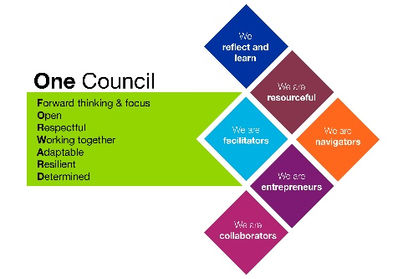
Role models and
demonstrates the
Council’s values and
behaviours

All staff should hold a duty and commitment to observing the Council’s Equality & Diversity policy and procedures at all times. Duties must be carried out in accordance with relevant Equality & Diversity legislation and Council policies/procedures.

