

JOB DESCRIPTION

Job Title | Electoral Technician

Salary | £23,541-£28,672 per annum

Directorate: | Delivery | Section/Location: | Electoral Services
Grade/Salary Range: | H – SCP 15 to SCP 24 | Work style: | Home Flex

Key Objectives of the role
To be responsible for the efficient administration and maintenance of the digital electoral management system.

To assist in the preparation, publication and maintenance of the register of electors.

To support key aspects of the planning and delivery of elections and other electoral events.

Designation of post and position within departmental structure
The Electoral Technician works within the Democratic and Registration services division of the Service Delivery directorate. The post holder is managed by the Electoral Services Manager
under the overall direction of the Head of Democratic and Registration Services.

Daily and monthly responsibilities
- To maintain and ensure the efficient administration and upkeep of the digital electoral management system, including the updating of electoral software and liaison with software supplier to report system problems and ensure open cases are resolved in good time.

- To contribute to team learning sessions and share good practice to ensure a consistent team approach to work.

- To maintain the absent vote and special category elector records on the electronic electoral management system and publish these as and when required.

- To deal with routine enquiries from the public, elected members, officers and other government bodies relating to electoral registration and elections.

- To manage the sale and distribution of the register of electors including tracking and monitoring processes in accordance with the relevant legislation and internal policies and procedures.

- To assist the Electoral Services Manager with specific registration tasks including the provision of support with electoral reviews.

- To lead on routine election projects and to contribute and assist in the delivery of more complex election projects.

- To provide support to specific member working groups, including clerking meetings, publishing agendas and other relevant paperwork.

- To be responsible for the collection of notifications from Tell Us Once electronic system and implementation of any changes.

- To assist in the development of promotional strategies and public engagement events in order to encourage registration and participation.

- To input, maintain and retrieve electoral registration records using digital and manual systems, verifying the accuracy of information held and to undertake routine electoral registration tasks as required.

- To support the wider Democratic and Registration Services team with other work as required.

- Such other duties that may from time to time be necessary, compatible with the nature of the post. It should be noted that the above list of main duties and responsibilities is not necessarily a complete statement of the final duties of the post. It is intended to give an overall view of the position and should be taken as guidance only

Scope of role
The post holder has interaction with other members of staff, elected Members, the Association of Electoral Administrators, Royal Mail, electoral software suppliers and the general public. The post is key to the provision of statutory responsibilities for electoral registration, elections and referendums.

There is no budgetary or supervisory responsibility.

Such other duties as may from time to time be necessary, compatible with the nature of the post. It should be noted that the above list of main duties and responsibilities is not necessarily a complete statement of the final duties of the post. It is intended to give an overall view of the position and should be taken as guidance only.



PERSON SPECIFICATION
KEY CRITERIA | ESSENTIAL | DESIRABLE
Skills and qualifications | Educated to A - level or equivalent.  Commitment to continual improvement of personal and professional knowledge and performance. | Educated to degree level, or equivalent  AEA Certificate in Electoral Administration.  ECDL
Competence Summary  (Knowledge, abilities, skills, experience) | High level of IT competence.  Ability to understand rules and laws and apply them correctly to specific tasks and processes.  Strong organisational and administrative skills and the ability to apply these to a range of electoral activities.  Ability to communicate effectively both verbally and in writing with a variety of internal and external stakeholders.  Ability to work effectively under pressure with the skill to co-ordinate, plan and prioritise own work when faced with conflicting priorities.  Ability to work accurately with attention to detail at all times. | Experience and knowledge of electoral registration and electoral processes.  Knowledge of information security and appropriate data management.  Knowledge of an electoral management system (preferably Xpress).  Knowledge of project management methodologies e.g. PRINCE2.
Work-related Personal Requirements | Effective interpersonal skills with the ability to form working relationships with a range of internal and external stakeholders.  Politically sensitive and astute.  Ability to exercise tact, diplomacy, sensitivity and confidentiality whilst undertaking duties. | Current driving licence and use of car
Other Work Requirements | Flexibility and requirement to work additional hours, including some evenings and weekend work during specific activities. Such as at elections.  Restrictions on taking annual leave during election and canvass periods.  Adherence to guidance issued by the Returning Officer, Electoral Commission and/ or the Cabinet Office in relation to working practices and political impartiality.  A basic DBS check (required for Tell Us Once service).  To understand, implement and carry out duties in accordance with the Council’s Equal Opportunity Policy.

KEY CRITERIA | ESSENTIAL | DESIRABLE
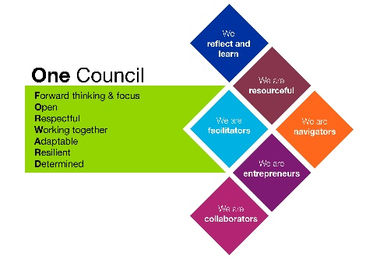
Role models and
demonstrates the
Council’s values and
behaviours

