

JOB DESCRIPTION

Job Title | Relief Residential Child Care Officer

Salary | 10.14 per hour to £11.64 per hour + London Weighting

Directorate: | People | Section/Location: | Larchwood
Grade/Salary Range: | BG-I 18-23 | Work style: | Fixed

Key Objectives of the role
- To work as part of a team providing a range of services to children with disabilities.

Designation of post and position within departmental structure
DIRECTOR OF CHILDREN, YOUNG PEOPLE AND LEARNING
│
ASSISTANT DIRECTOR, CHILDREN’S SOCIAL CARE
│
HEAD OF SERVICE
│
REGISTERED MANAGER
│
SENIOR PRACTITIONER
│
CHILDREN’S RESIDENTIAL CARE AND SUPPORT WORKER

Relief Children’s residential care and support worker

Daily and monthly responsibilities
1. As a relief children’s residential care and support worker to support the delivery of short break care options within the Larchwood Short Break Unit, both overnight and during the daytime. This includes supporting the delivery of weekday, weekend and week-long overnight breaks as determined by the Larchwood Management Team.

2. To provide outreach support and care for children and young people and their families in their own homes and/or elsewhere, working in accordance with the relevant regulations and requirements for safe care and in accordance with the support programme agreed with the family. This may be work undertaken together with the Short Break Behaviour Support Team or similar resource.

3. To participate in the delivery of respite care and support for the children and young people away from the unit to enable them to attend weekend activity breaks at approved centres or other risk assessed locations.

4. To work within individual care plans, which are consistent with national guidance for person centred planning and include clear individual risk management strategies.

5. To work within the policies and procedures of the Department and of the individual Services and Teams particularly with regard to all relevant aspects of personal care and behaviour management,

6. To promote the welfare of children and young people and to contribute to ensuring
that children are safeguarded from abuse.

7. To participate in all appropriate internal/external training as identified through the supervision and appraisal system, and to follow a personal development programme for utilising the skills and knowledge gained.

8. To be fully aware of the requirements of the Children’s homes regulations and Ofsted as these apply to the Larchwood Unit and to work in accordance with them.

9. To undertake additional duties as required and commensurate with the level of the post.

Scope of role
To be aware that the support offered is scrutinised by Ofsted Inspection. As such, individual support staff have a crucial role to play in enabling Larchwood to demonstrate the delivery of safe and supportive short break care packages within the unit and to implement empowering, flexible approaches to supporting children and young people in the community.

The post will have no specific budgetary responsibilities.

All employees working with children, young people and vulnerable adults have a responsibility for safeguarding and promoting their welfare

Such other duties as may from time to time be necessary, compatible with the nature of the post. It should be noted that the above list of main duties and responsibilities is not necessarily a complete statement of the final duties of the post. It is intended to give an overall view of the position and should be taken as guidance only.

PERSON SPECIFICATION
KEY CRITERIA | ESSENTIAL | DESIRABLE
Skills and qualifications | Level 3 Diploma for Residential Childcare /N.V.Q Level 3 in Caring for Children and Young People or willingness to work towards.  A qualification in childcare or equivalent  Experience of working with children with additional needs and their families.
Competence Summary  (Knowledge, abilities, skills, experience) | Good verbal and written communication skills and ability to work within care standards.  A commitment to the principles of respect, independence, choice and inclusion and an understanding of the practical implications of this.  Willingness and ability to undertake work related training and utilise new skills and knowledge to enable improved support.  Confident in I.T systems.  Understanding of and commitment to the requirements of safeguarding children and young people. | Experience of individuals with challenging behaviour, self-injurious behaviour, autism, mental health issues.  Previous experience of working in a caring environment and/or with people with a learning difficulty or disability.  Experience of working as part of a team
Work-related Personal Requirements | Ability to work under pressure  Ability to relate to and empathise with individuals with a learning difficulty and/ or disability.  Ability to liaise professionally with families and other agencies  Receptive to new ideas and able to accept changes.  Right to work in the UK | Trained in Team Teach or an alternative positive handling strategy
Other Work Requirements | A satisfactory enhanced Disclosure and Barring Service check.  Able to work within the manual handling policy of BFC.  Need to be flexible in patterns of work to support the service and needs of individuals.  To work in a variety of settings including Larchwood Short Break Unit, family homes, leisure and recreational settings, and potentially residential trips away.  Able to travel to and from work settings in unsociable hours.  Mentally and physically fit for the role.

KEY CRITERIA | ESSENTIAL | DESIRABLE
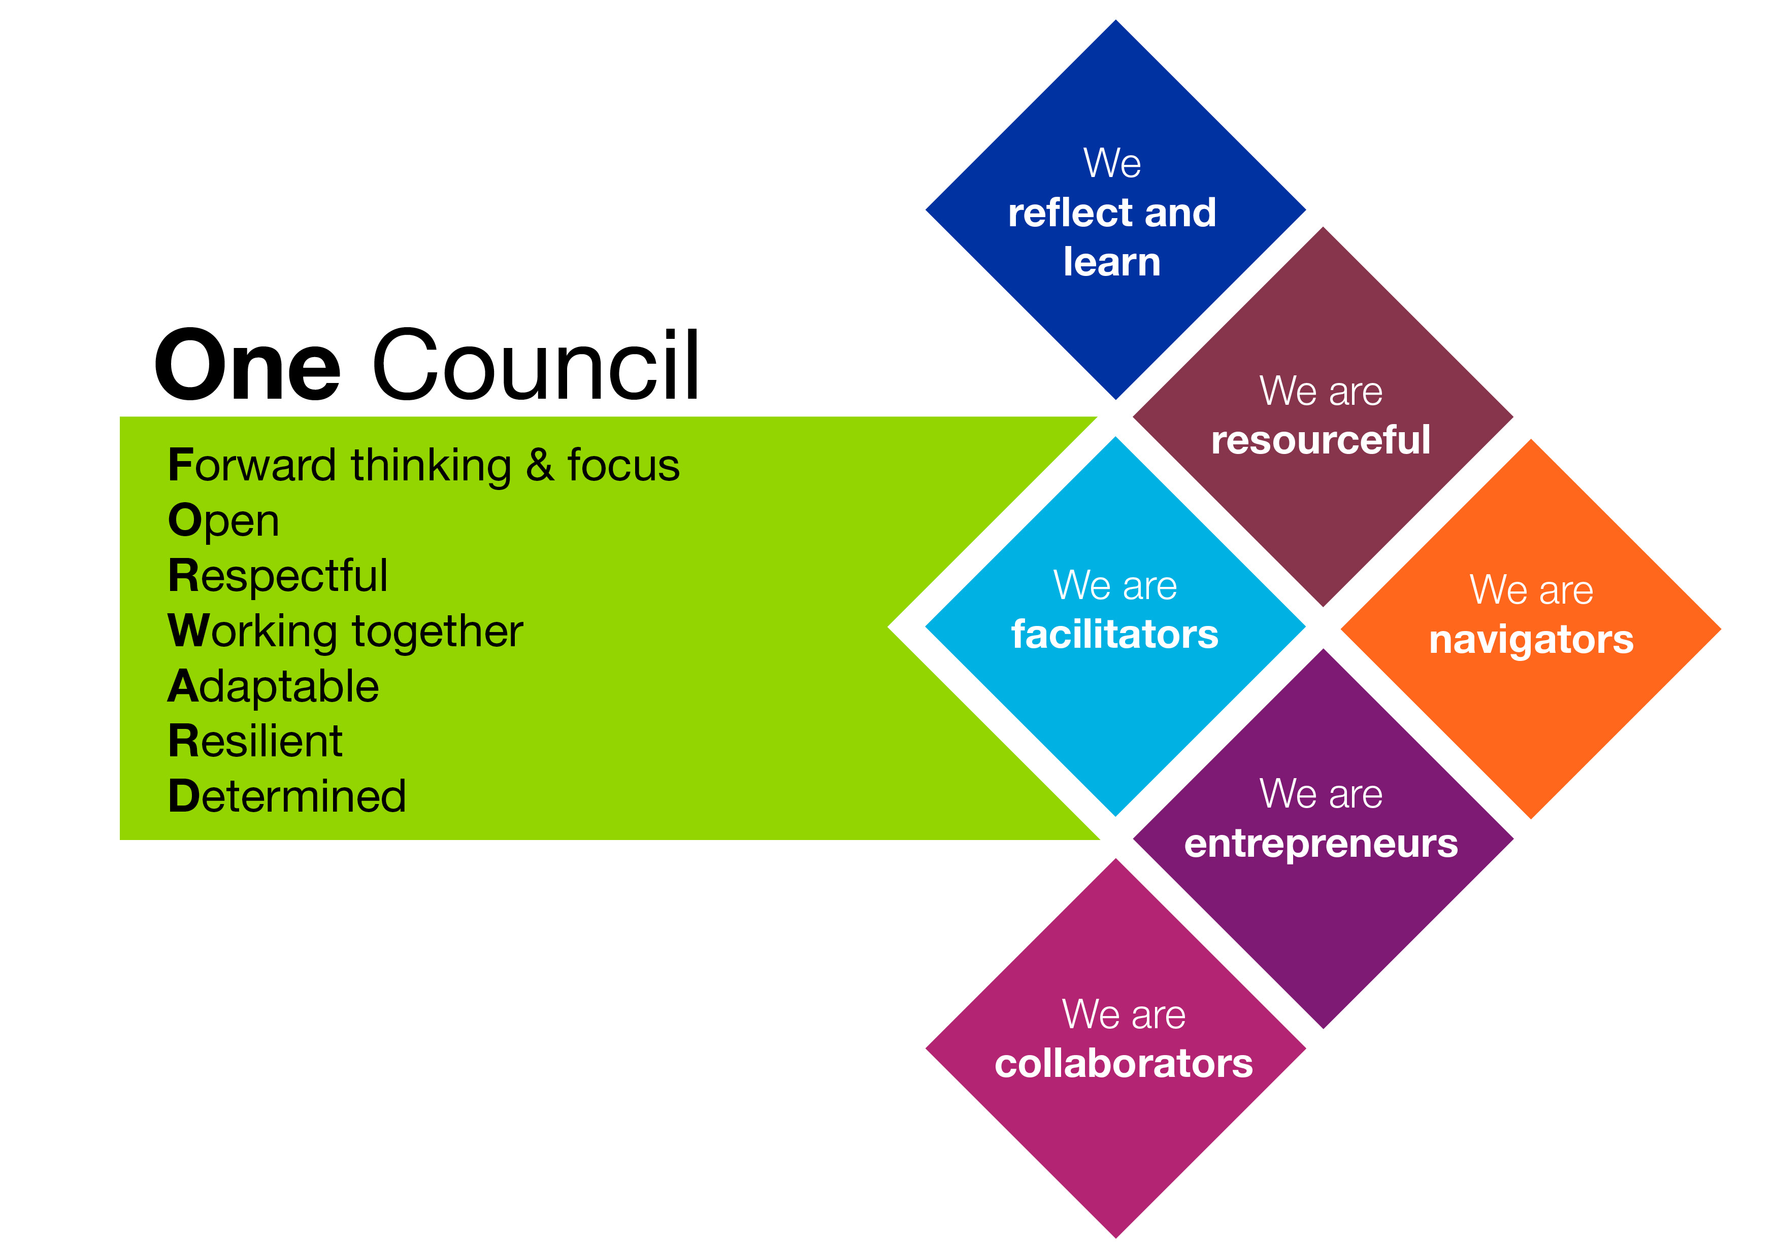
Role models and
demonstrates the
Council’s values and
behaviours

