

JOB DESCRIPTION

Job Title | Business Intelligence Analyst

Salary | £28,785 to £32,878 + £609 London weighting

Directorate: | People | Section/Location: | Business Intelligence
Grade Range: | BG-G SCP 25-30 | Work style: | Home-Flex

Key Objectives of the role
- Undertake investigation of data; carry out statistical analysis and make recommendations on data quality and performance issues across the directorate.
- To engage with internal and external customers to understand their business requirements and deliver solutions that meet their data and analysis needs.
- Be a key player in preparing and submitting statutory returns to central government and other agencies.
- To develop tools, dashboards and systems to support data extraction, integration and analysis.
- To identify and develop innovative solutions to improve the efficiency, effectiveness and automation of reporting processes.

Designation of post and position within departmental structure

Daily and monthly responsibilities
- To complete statutory returns to central government and other regulatory bodies as required.
- To utilise data reporting tools to scope and design advanced suites of data quality and performance information reports for statutory reporting, performance and data quality monitoring and freedom of information and ad-hoc requests.
- Create and develop reports, dashboards and data visualisations using available software eg. Business Objects and Excel.
- To pro-actively develop links with internal and external stakeholders to assist with and promote quality assurance and performance monitoring systems.
- To analyse, interpret and propose recommendations and action plans from a wide range of information and data, including data from consultations, audit findings, other quality assurance systems and performance indicators.
- To pro-actively work with and support senior managers, managers and teams across the directorate and partner organisations, as appropriate, to develop and implement plans to improve the recording and reporting of performance.
- Support the team and service on projects involving the management of data, intelligence, reporting and the development of data reports and visualisations.
- To support managers and teams with the development of quality and service standards for people who use our services and the wider community and to monitor compliance with those standards.
- To prepare and present high-quality reports that will provide the basis for strategic decision making across the directorate.
- To network and research best practice and performance improvement ideas and opportunities.
- To represent senior colleagues, as necessary, within the council.
- To keep up to date with national statutory reporting guidance and the performance framework agenda and its impact upon local practice and performance within the department.

Scope of role
The post will report to the Senior Business Intelligence Analyst. The post has no budget or line management responsibilities.

The post has responsibility for ensuring, along with the Senior Business Intelligence Analyst and Deputy Head of Business Intelligence, that the statutory government returns are completed on time.

Such other duties as may from time to time be necessary, compatible with the nature of the post. It should be noted that the above list of main duties and responsibilities is not necessarily a complete statement of the final duties of the post. It is intended to give an overall view of the position and should be taken as guidance only.



PERSON SPECIFICATION

KEY CRITERIA | ESSENTIAL | DESIRABLE
Skills and qualifications | Educated to degree level or equivalent standard of education, or qualified through relevant work experience.
Competence Summary  (Knowledge, abilities, skills, experience) | Relevant experience of advanced collating, reporting, handling and interpreting of large data sets in relation to data quality and performance monitoring.  Experience with reporting, query and analysis tools eg. SAP Business Objects.  Excellent spreadsheet skills eg. vlookups, pivot tables and data manipulation, with the ability to summarise and organise data effectively.  Experience of using all MS Office applications and advanced use of Word and Excel. The ability to adapt quickly to new software.  Ability to collate, analyse and present data in a variety of formats and to different audiences.  Ability to analyse and interpret oral and written information, including statistics.  Experience of working with a range of statutory and other organisations.  Ability to develop service and performance monitoring systems.  Ability to respond quickly to requests, promptly find solutions and work accurately under pressure. This requires a high level of innovation. | Experience of working in a public body with a social care setting.  Knowledge and experience of completing adult social care statutory returns.  Experience of SQL and data insight tools such as Tableau or PowerBI.  Experience of advanced use and reporting from adult social care databases, in particular Liquidlogic's LAS Protocol.  Using a range of statistical techniques for data analysis.
Work-related Personal Requirements | Display a high level of self-motivation, with the requirement to be able to use initiative.  Highly numerate, with excellent analytical and problem-solving skills.  Ability to work under pressure with a high degree of accuracy, and to manage and prioritise a diverse workload, whilst meeting deadlines.  Flexible and reliable.  Willing to respond to requests, open to new ideas and being innovative.  Excellent communication skills (both verbal and written) when dealing with a wide range of colleagues and stakeholders.  Build and maintain effective relationships through effective interpersonal skills.
Other Work Requirements | A satisfactory enhanced Disclosure and Barring Service check.  Understanding, and commitment to, the principals and practices of valuing diversity and equal opportunities.  Understanding and knowledge of data protection/sharing issues and legislation.
The council’s values and behaviours | 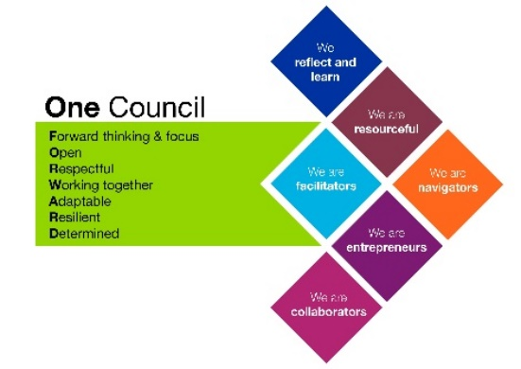

Last updated: August 2019

