

JOB DESCRIPTION

Job Title | Mental Health Practitioner – Homeless Outreach

Salary | £28,785 to £32,878 + £609 London Weighting (based on full time  hours)

Directorate: | People | Section/Location: | Welfare & Housing  Service, DAAT, CMHT  Time Square
Grade/Salary Range: | BG-G, SCP 25-30 | Work style: | Free

Key Objectives of the role
- To work with clients identified by the Welfare and Housing Service who are rough sleeping in the borough or those at risk of homelessness who have a history of rough sleeping and who present with offending, substance misuse and mental health needs. The post holder will be responsible for assessing, engaging and delivering meaningful treatment interventions to service users with dual diagnosis needs.

- To continuously assess the psychological, emotional, social and rehabilitative needs of dual diagnosis service users, whilst taking in to account recovery care planning and the evaluation of treatment plans.

- To develop, strengthen and maintain partnership relationship with statutory and voluntary sector mental health services ensuring a corporate approach is adopted and to work in partnership with adult social care ensuring an effective referral pathway for clients who need social care assessments.

Designation of post and position within departmental structure
This is a new post within the Welfare and Housing Resources team on a 12 month fixed term contract. This is an integrated post within 3 service areas, the Welfare and Housing Service, Drugs and Alcohol Team, and Community Mental Health Team and will be expected to work flexibly within these services. For the purposes of specialist reflective/clinical supervision the post will be reporting to the Head of Drug and Alcohol Service and Community Mental Health Team

However, this post is ring-fenced to work with rough sleepers in the borough and various projects supporting this cohort of individuals as identified by the Rough Sleeper Team Manager and as such management on specific projects and operational management will be with the Rough Sleeper Team Manager.
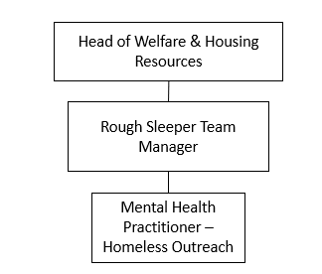

Daily and monthly responsibilities
- To conduct comprehensive assessments of individuals’ substance misuse, mental health and offending support needs.

- To conduct comprehensive risk assessments, drawing on a range of data sources.

- To complete effective risk management/safety plans to manage an individual’s risk to self and others and to refer to safeguarding when assessing and managing the risks.

- To manage a small caseload and complete recovery-focused, holistic care plans with individuals that address their substance misuse, mental health and criminogenic support needs, in addition to other holistic support needs.

- To deliver a range of specialist substance misuse, mental health and reducing offending interventions to service users.

- To maintain accurate and timely case notes of service user engagement and progress, and up to date outcomes records on internal databases.

- To work proactively and flexibly to prevent service users from dropping out of treatment and re-engage them if they do.

- To make appropriate referrals to partner agencies for specialist interventions.

- To report on a regular basis in terms of outcomes achieved and contribute to service team and multi-disciplinary team meetings.

- To maintain and develop relationships with professionals external to the area of the service, service users within the area of service/specialism.

- To provide advice to other members of the service and agencies on the particular needs of service users.

Scope of role
This post holder will have access to a dedicated budget to use as required in order to help achieve outcomes for clients.

The post involves working with other team members as part of a specialist team supporting rough sleepers in the borough and will require liaison with other agencies as part of a multi-disciplinary team.

The post involves lone working and visiting vulnerable clients and the post holder will be required to use Councils laptops in that context which will hold category 3 level information.

All employees working with children, young people and vulnerable adults have a responsibility for safeguarding and promoting their welfare.

Such other duties as may from time to time be necessary, compatible with the nature of the post. It should be noted that the above list of main duties and responsibilities is not necessarily a complete statement of the final duties of the post. It is intended to give an overall view of the position and should be taken as guidance only.



PERSON SPECIFICATION
KEY CRITERIA | ESSENTIAL | DESIRABLE
Skills and qualifications | Degree in Mental Health Nursing or Registered Mental Health Social worker with evidence of professional development. Registered with HCPC.  Specialist knowledge of dual diagnosis issues and experience of working within the mental health or substance misuse field, including with alcohol users.  Competent IT skills and the ability to navigate around various systems and software packages (such as outlook, databases, MS office and the internet).
Competence Summary  (Knowledge, abilities, skills, experience) | Previous knowledge and experience of recovery focused service provision with individuals who have complex mental health needs, substance misuse and offending behaviour.  Experience of assertive outreach and interventions with individuals with complex needs.  Substantial experience of managing a busy caseload of individuals with dual diagnosis.  A commitment to establishing partnerships with other professions to achieve good outcomes for the client group, e.g. mental health services, criminal justice agencies, community groups.  Ability to work with clients at different stages of behaviour change and make appropriate assessment of needs.  Experience of conducting assessments and developing, implementing and evaluating care plans.  Awareness and experience of person-centred planning.  Understanding of and experience of using the Care Programme Approach.  Excellent knowledge and understanding of relevant health and social care legislation including the Mental Health Act 1983, Mental Capacity Act 2005 and the Care Act 2014  Effective and competent interpersonal, influencing, communication, observation and reporting skills.  Ability to work collaboratively with others, internally and externally.  Strong organisational skills and the ability to analyse situations and be able to make the right decisions.  Able to empathise, be supportive and sensitive to the needs of others as well as being able to cope with distressing circumstances.  Ability to cope in a pressurised environment and apply practical problem-solving skills in everyday situations.  Able to work flexibly on a shift pattern as required and the ability to travel independently between locations to fulfil the requirements of the position.  Ability to work effectively in a team, work on own initiative, work unsupervised and manage own workload.  Manage individuals who have complex needs and challenging behaviours.  Ability to promote service user involvement and integration in to the wider programme.  Understanding of and commitment to the requirements for Safeguarding Children, Young People and Vulnerable Adults.  Understanding of and commitment to the requirements of the General Data Protection Regulation (GDPR).  Commitment to equal opportunities and overcoming barriers to diversity and equality.
Work-related Personal Requirements | Ability to work within set policies and procedures.  The post holder must have access to own transport.  The post holder will be required to work evenings and weekend hours when required.
Other Work Requirements | A satisfactory enhanced Disclosure and Barring Service check.

KEY CRITERIA | ESSENTIAL | DESIRABLE
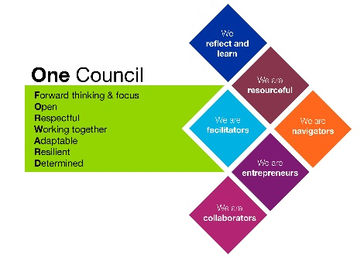
Role models and
demonstrates the
Council’s values and
behaviours

